Mendota News
City of Mendota
P. O. Box 50688
Mendota, MN 55150
Phone: 651-322-0827
Email: cityofmendota@gmail.com
Kathy Krotter, City Clerk
Council Members:
Brian Mielke, Mayor: 651-261-2751
Joan Perron: 651-452-9359
Steve Golias: 651-452-1837 Melody Rasmussen: 651-454-6442
Clark Donnelly: 651-785-5790
Building Permits:
Mike Andrejka, Building Official: 612-597-9667
Mailing Address: 1011 Sibley Memorial Highway,
Lilydale, MN 55118
Police:
Kelly McCarthy, Chief of Police: Non-emergency: 651-452-1366
Emergency: 911
Fire:
Emergency: 911

City Attorney:
Tom Loonan, City Attorney:
715-808-8842

The City of Mendota holds City Council Meetings at 7:30 on the second Tuesday of every month upstairs at the
VFW Post 6690
1323 Sibley Memorial Hwy.
Mendota, MN 55150

Winter 2022

Annual Tree Lighting!
The annual tree lighting ceremony is on again this year. It will be the Saturday after Thanksgiving, November 26, 2022. This year please bring your old and broken Holiday lights to the tree lighting for recycling. String lights and electrical cords don’t belong in your recycling cart. They wrap around machines at sorting facilities and cause damage. Help the city clerk reach 100 lbs. in Holiday lights and old extension cords to bring into the recycling center. Thanks

Join your neighbors to keep food scraps out of the trash
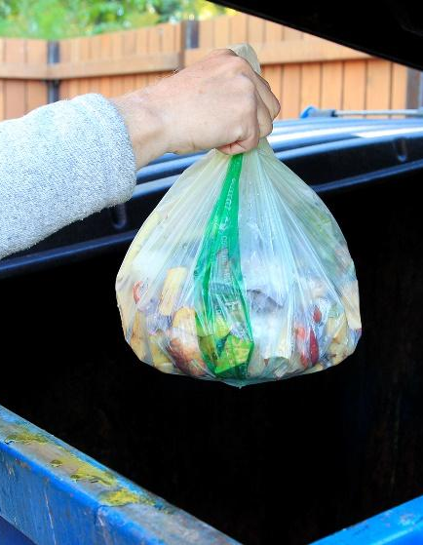
The number one item in our trash is food and it’s finding its way to the landfill. That’s why more than 9,000 Dakota County households have registered to participate in the free organics drop-off program. Across all nine locations, more than 10,000 pounds of food scraps and other compostable products are collected each week.
Bringing organics to a drop-off site is easy and can dramatically reduce waste. The typical household can divert up to one-third of trash by delivering items such as food scraps, spoiled produce, coffee grounds and bones. Instead of sitting in a landfill, this material is turned into compost used in gardening and landscaping.
Sites are located throughout the county. Our closest sites are in Mendakota Park in Mendota Heights and Thompson County Park in West St. Paul.
To sign up, visit www.dakotacounty.us and search organics, email organics@co.dakota.mn.us or call 952-891-7557. All registered participants receive helpful tips and compostable bags to use at home.
Partially funded by the Minnesota Pollution Control Agency and Dakota County.

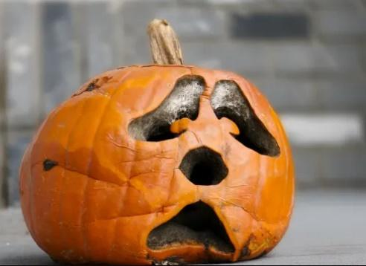
When pumpkins turn scary
Rotten pumpkins can be composted in your backyard or picked up with your yard waste. You can also drop off pumpkins at a yard waste site for as little as $1 per 30-gallon yard waste bag. Most cities will collect pumpkins the first weekend of November at a drop-off site for free – see event listing below. Remove candles, wax and any non-pumpkin material. No painted or glittered pumpkins can be composted — these must go in the trash.

Avoid the holiday tangle
String lights and electrical cords don’t belong in your recycling cart. They wrap around machines at sorting facilities and cause damage. Instead, bring holiday lights and extension cords to participating locations through Jan. 31 for recycling. The closest locations to us are:
- Eagan: Lebanon Hills Visitor Center, The Recycling Zone
- Mendota Heights: City Hall
- South St. Paul: City Hall
- West St. Paul: Dakota County Northern Service Center
Look for collection bins near the entrance. Check location hours before dropping off.

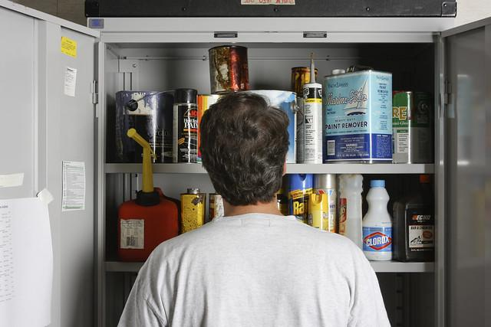
Make the garage cleanout easy
As cold weather arrives, you might be faced with tidying up the garage. Make the chore less of a pain with one stop at The Recycling Zone. Pull up, drop off, and we’ll do the rest.
Bring the following for free, unless noted:
- Auto products – Antifreeze, gasoline and used oil
- Batteries – All types. Please tape both ends of small batteries with clear tape
- Paints and stains
- Light bulbs – Any type or size
- Lawn and garden chemicals
- Pool and spa chemicals
- Cardboard – Break down boxes, cut to be no larger than 36 inches by 36 inches
- Grills, lawn mowers, snow blowers – Drain fluids and bring in separate, labeled containers
- Holiday lights, timers and extension cords
- Metal tools – Drills, screwdrivers, sanders, small saws and more
- Lawn equipment – Metal wheelbarrows, garden tools and edgers
- Tires – Fee per tire starting at $5
Fill up your vehicle, and we unload for you. Bring smaller items in a box or bag that can be left behind. Find out what else you can bring and guidelines for dropping off at www.dakotacounty.us, search recycling zone.

