Mendota News



**City of Mendota**

P. O. Box 50688

Mendota, MN 55150

Phone: 651-322-0827

Email: [cityofmendota@gmail.com](mailto:cityofmendota@gmail.com)

Kathy Krotter, City Clerk

**Council Members:**

Brian Mielke, Mayor: 651-261-2751

Joan Perron: 651-452-9359

Steve Golias: 651-452-1837

Melody Rasmussen: 651-454-6442

Kathleen Krotter: 651-454-3913

**Building Permits:**

Mike Andrejka, Building Official:

612-597-9667

Mailing Address: 1011 Sibley Memorial Highway, Lilydale, MN 55118

**Police:**

Kelly McCarthy, Chief of Police:

Non-emergency: 651-452-1366

Emergency: 911

**Fire:**

Emergency: 911

**City Attorney:**

Tom Loonan, City Attorney:

651-439-2878

**The City of Mendota holds City Council Meetings at 7:30 on the second Tuesday of every month at the**

**VFW Post 6690**

**1323 Sibley Memorial Hwy.**

**Mendota, MN 55150**

Winter 2018

Annual Tree Lighting!

This year was our 8th Annual Tree Lighting. Mayor Mielke and his wife, Nancy did another wonderful job putting all this together for us. Special thanks to Dan and Arlene Dahlberg and Joe and Gloria Schaefer for always helping get the tree ready for the big day. Thanks to everyone who participated and hung out to enjoy hot chocolate and cookies. Christmas Carols and talking with friends and neighbors, what a way to spend the night. Thanks again Brian and Nancy!!!

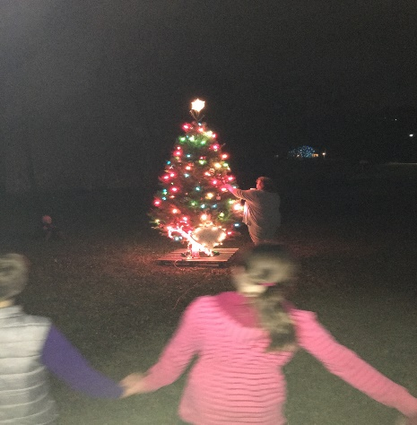

Snow plowing

Now that winter is here, the City of Mendota asks the residents to be aware of city ordinances relating to parking and snow shoveling.

**In order to keep city snow removal costs down, please adhere to the following practices:**

* Please do not park in such a manner as to obstruct or interfere with the snow plowing or snow removal.
* **Also**, it is unlawful for any person to deposit snow/ice in the roadway.
* All snow and ice should be removed from public sidewalks 12 hours after the snow has ceased to fall. Thank you for your cooperation in this manner.

**Your snow plowing service will appreciate your efforts.**

FOOD WASTE

The best thing that can happen to food is that it makes it to our plates and is enjoyed. Avoiding throwing out food that could have been eaten will save you money and help reduce greenhouse gas emissions. However some food waste is inevitable - egg shells, banana skins and tea bags are never going to be on the menu.

Home composting is a great way to stop this sort of waste ending up in landfills, and our gardens will really thank us for it. And home composting is pretty easy to do. We also live in an area that has food waste or organic recycling. We have two collection spots one in West St Paul and the other in Eagan.

Did you know?

Around 7 million tons of food is thrown away by households and most of it could have been eaten.

Some of the waste is made up of things like peelings, cores and bones, but the majority is, or once was, perfectly good food.

Most of it ends up in landfill sites where it rots and releases methane, a damaging green house gas. Throwing away food is also a huge waste of the energy, water and packaging used in its production, transportation and storage. If we all stopped wasting the food which could have been eaten, it would have the same CO2 impact as taking 1 in 4 cars off the roads.

The amount of food we throw away is a waste of resources. Just think about all the energy, water and packaging used in food production, transportation and storage. This all goes to waste when we throw away perfectly good food.

Cheese is a good example – feeding and milking the cows, cooling and transporting the milk, processing it in to cheese, packing it, getting it to the grocery stores, keeping it at the right temperature all the time. If it then gets thrown away it will most likely end up in a landfill site, where, rather than harmlessly decomposing as many people think, it rots and actually releases methane, a powerful greenhouse gas.

Issues and solutions

Don't forget to make the most of your food and drink and try to avoid wasting food in the first place. For ideas, recipes and simple tips visit Love Food Hate Waste. You could also try to compost at home.

A food waste container in your kitchen can help you to separate out your food waste for recycling and composting. (I use an old coffee container.) This can be emptied into your compost bin or organic recycling centers every couple of days. Where possible keep your bins out of direct sunlight and keep the bin lid closed. Adding leaves to the compost helps break down the food and make the best soil for planting.

Find out more and watch some top food recycling tips videos

RECYCLING KNOWLEDGE: Check out the web for these great ideas.

Getting started

How is it recycled?

Recycling around the home

Recycling collections

Recycling centers

Food waste

Garden waste

Food recycling

**Dakota County has some great recycling ideas and joining a Master Recycling class is an awesome way to learn more about recycling, the process and what you can do to help with recycling in your home and neighborhood.**