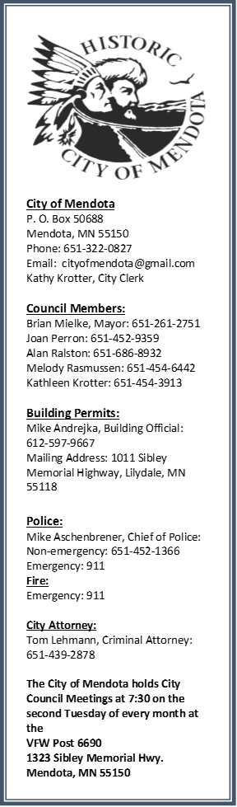
Mendota News
Fall 2016

The Mendota Picnic—September 10, 2016
Beginning at noon at Veteran’s Park
Hot Dogs and Pop Provided. Bring a dish to share.
Kids receive a raffle prize and an entry to win a bike
Horseshoe Tournament - Scavenger hunt for older kids.
Bounce House - Music
Mendota’s 17th Annual Traditional Wacipi-Pow Wow
St Peter’s Church Grounds in Mendota, Minnesota
1405 Sibley Memorial Hwy 55150

Friday, Sept. 09
5:05 pm ...Lighting the Sacred Fire (followed by a potluck dinner)
Saturday, Sept 10
11:00 am ...Dancer Registration
1:00 pm ...Grand Entry / Honored Guards
3:30 pm ...Honor our Veterans
5:00 pm ...Dancer Registration
5:45 pm ….Mexica Dancers
7:00 pm ...Grand Entry / Honored Guards
8:00 pm ...Men’s & Woman’s Traditional Contest Dance
8:45 pm ...Registered Dancers Payout

Sunday, Sept 11
11:00 am...Dancer Registration
1:00 pm ...Grand Entry / Honored Guards
2:30 pm ...TBA
3:30 pm ...TBA
5:30 pm ...Closing Ceremony & Feast
5:00 pm ...Registered Dancers Payout

$5.00 Entry Button Donation, no one turned away. Info call 651-452-4141
Snow Removal
The City of Mendota asks residents to be aware of city ordinances in regards to parking and snow removal. Please do not park in such a manner as to obstruct or interfere with snow plowing or snow removal. Also, it is unlawful for any person to deposit snow/ice into the roadway. All snow and ice should be removed from public sidewalks 12 hours after the snow has ceased to fall.
The city thanks you for your cooperation.

Autumn Leaves
Wherever leaves fall, they decompose and restock the soil with nutrients and organic matter.
But when there is no soil to land on—such as on a street or sidewalk—the leaves and all their decomposing bits wash down the street and into the storm drain. They go directly into lakes and rivers where the nutrients will feed unwanted algae growth next summer. In addition to a major "ick" factor, this algae is a problem because when it dies and decomposes at the bottom of the lake it uses up oxygen that fish and native plants need.
Put leaves in your backyard compost pile:
One of the best ways to use leaves (from the street or the yard) is to compost them in your backyard. Learn how to compost in your backyard with leaves to mulch your garden and lawn.
Whole or shredded leaves can be used as mulch. Mulch benefits the soil and reduces weeds. On the lawn, use a mower to break apart the leaves so that they fall between the blades of grass. Don't let the leaf layer get too thick! In garden beds, leaves provide a protective layer of insulation for perennial gardens and shrubbery, either bagged or loose.

Election Year
Not only is this a presidential election year but it is also a big election year for Mendota.
The Mayors term is up, and the council has two seats open. The mayor’s term is a two year term and the council member term is a four year term.
2016 Election Information:
Register to Vote!
Minnesota Voter Registration Applications are available online at www.co.dakota.mn.us or at the Dakota County Northern Service Center in West St. Paul.
Name or Address changes require re-registration.
General Election: November 8, 2016
Polls are open from 7:00 a.m. to 8:00 p.m. at the Dupois House.
Out of Town during the Election?
You can vote by absentee ballot. To apply for an absentee ballot, stop by the Dakota County Northern Service Center located at 1 Mendota Road, West St. Paul, MN 55118. You can ask related election questions by calling 651-554-6000, or visiting the county website at www.co.dakota.mn.us.

Hope to see you at the Mendota Picnic and on Election Day.

