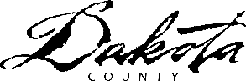

Recycling

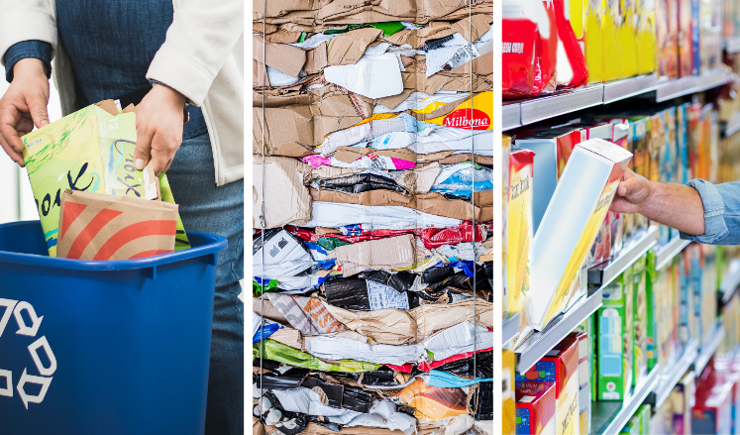
Minnesota recycling works
Have you ever questioned if recycling is worth it? Short answer: yes. Beyond saving energy and protecting natural resources, recycling also supports vital industries.
Recycling is the process of collecting materials that would otherwise be thrown away and turning them into new products. Our cans, bottles and paper are dropped off at a local facility where people and machines sort the recycling into material types which are sent to many different companies:
- Paper and cardboard are made into newspapers, toilet paper rolls and cereal boxes at five paper mills in Minnesota.
- Cartons like juice boxes are sent to a company in Wisconsin that makes a material for new paper products.
- Aluminum cans get turned into new cans, wire, siding and more at plants in the South.
- Steel cans like those used for soup are made into steel beams in Chicago.
- Plastic bottles with a number 1 like water and soda bottles are shipped to other states to be made into new bottles and carpet.
- Plastic containers with a number 2 like milk jugs are transformed into low-maintenance lumber by companies like Avon Plastics in Paynesville.
- Cottage cheese and other plastic tubs with a number 5 are used to create food containers, car parts and more by companies in other states.
- Glass bottles and jars are sorted by color in St. Paul. Clear glass goes to Anchor Glass in Shakopee to make condiment bottles. Brown glass is sent to Illinois to make beer bottles.
Our recycling is wanted by many companies in our state and across the country. Help support local recycling business:
- Stick to the basics: Recycle the items listed above.
- Keep it loose: Empty recycling into your bin – no plastic bags.
- Check the Recycling Guide for everything else. www.dakotacounty.us, search recycling guide].
Partially funded by the Minnesota Pollution Control Agency and Dakota County.

2023 Required Newsletter Articles

Recycling Zone

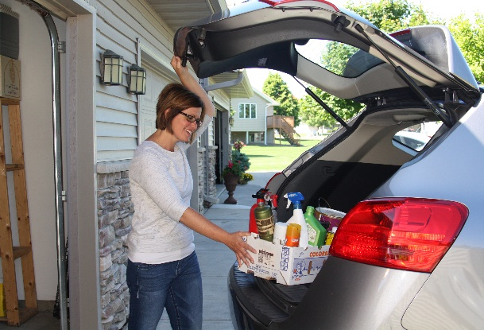
Declutter cleaners for a fresh start
Sprucing up your home should include properly cleaning out unwanted chemical cleaning supplies. Don’t wait to declutter your surplus of cleaning sprays and unused drain cleaners. Gather all your cleaning products and potentially hazardous items from under-the-sink, storage closets and garage. Keep what you would use in the next year and put everything else in a box to bring to The Recycling Zone.
The Recycling Zone is your one-stop drop-off for most products labeled caution, warning, danger or poison. Residents can bring cleaners, personal care products like nail polish and sunscreen, paint, yard and garden chemicals, bug killers and more for free.
The site is open four days a week all year. Find open hours, directions and the full list of items accepted at www.dakotacounty.us, search recycling zone.
Partially funded by the Minnesota Pollution Control Agency and Dakota County.

2023 Required Newsletter Articles

Organics

For cities without a new organics drop-off site opening in 2023.

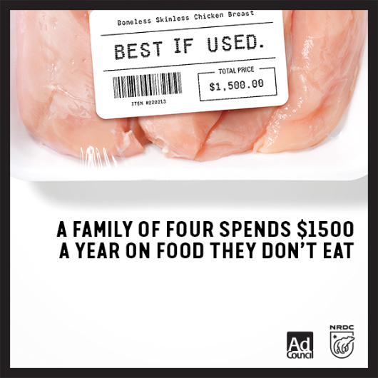
Wasted food is wasted money (or Save money by saving the food)
No one wants to waste food. Yet 40 percent of all food goes uneaten each year in the United States – wasting the water, energy, labor and land used to grow it. That waste adds up at home, too. All the spoiled meat and limp lettuce costs the average family of four $1,500 a year.
From farm to fridge, more food is wasted in our homes than any other part of the supply chain. Luckily, that means we have the power to make a difference in our own kitchens. Join the Save the Food Challenge to learn how to make small shifts in how we shop, prepare and store food to help reduce wasted food and save money.
Get tools and join the challenge at www.dakotacounty.us, search save the food.
And for all the banana peels and chicken bones that we can’t eat, sign up for Dakota County’s free Organics Drop Off program to turn food waste into beneficial compost.
Partially funded by the Minnesota Pollution Control Agency and Dakota County.

For cities with new sites in 2023

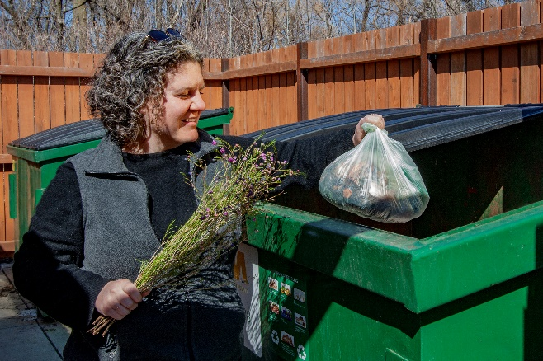
Food scraps drop-off site coming to [enter city]
Say ‘hello’ to the newest organics collection location in Dakota County. The [site name] drop-off site located at [street address], opens [date]. Residents can bring food scraps to the site for free — join our community challenge to have [number] residents sign up.
Organics collection goes beyond backyard composting by also accepting meat, bones and dairy products. The collected food waste goes to a commercial compost facility near Rosemount where it’s processed at higher temperatures to kill bacteria and break down larger pieces.
All participants receive helpful tips and free compostable bags to use at home. Sign up online at www.dakotacounty.us, search organics drop off, call 952-891-7557 or email organics@co.dakota.mn.us.
Partially funded by the Minnesota Pollution Control Agency and Dakota County.

2023 Required Newsletter Articles

Reduce/reuse

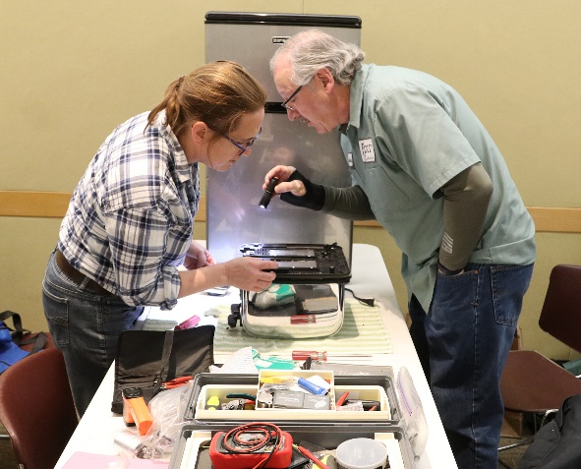
Free repair help for residents
Dakota County residents can get help repairing household items, clothes, electronics and more at a Fix-It Clinic. These monthly events help reduce unnecessary trash sent to landfills and empower individuals by teaching troubleshooting and repair skills.
Stop by an upcoming Fix-It Clinic on enter day, month and date from time at enter facility in enter city. The event is free, and residents do not need to register to participate.
Repair-saavy volunteers will guide you through each step, from troubleshooting to a completed repair. Bring up to three items that need fixing or mending such as lamps, vacuum cleaners and clothes. You must be able to carry items into the clinic, so no ovesized items. Bring any tools and supplies you think might help with the job; however, volunteers have plenty of tools.
For future dates and more information, visit www.dakotacounty.us and search Fix-It Clinics.

Partially funded by the Minnesota Pollution Control Agency and Dakota County.

